

**Educational and fun activity for groups of year 8 to 10 students**

*ENEL-300*

*16/10/2020*

*Author:*

*Jonathan Edwards 27033004*

# **Executive Summary**

The topic is about designing an educational and fun activity for groups of year 8 to 10 students. The approach I took in designing a project for the school children was to first identify what the supervisors wanted. Once I knew that they were expecting the electrical equivalent of the mousetrap car. I dove into my next question which was, what does the end-user want? The end-user being year 8 to 10 High school students. Once I chose my topic to be about magnets, I came up with experiment(s) which teaches them about what it is as to how to use it. My experiments were based on knowing:

* What will they learn?
* Why should they learn this?
* How will they learn this?

In the pursuit of teaching them the basics of magnets. I wanted to also be able to teach them about why they are useful in the real-life and in general. Students will learn the properties of a Magnet, principles of Magnetism, principles of Electromagnetism, Faraday’s Principle of Electromagnetic Induction and Lenz’s law.

While teaching/and theory is good, students will be conducting 3 experiments in groups of 4 to learn these. They will be making a compass, performing Faraday’s experiment and making a flashlight to show the student a real-life practical case.

**Contents**

**Executive Summary** i

**1.0** **Introduction** 1

**2.0** **Technical Specifications** 2

**3.0** **Learning Outcomes** 2

3.1. Properties of a Magnet 2

3.2. Principle of Magnetism 3

3.3. Principle of Electromagnetism 4

3.4. Faraday’s Principle of Electromagnetic Induction 4

3.5. Lenz’s law 5

**4.0** **Motivation** 5

**5.0** **Technical Experiments** 6

5.1. Experiment I – Compass 6

5.2. Experiment II – Faraday’s Experiment 7

5.3. Experiment III – Faraday’s flashlight 7

**6.0** **Drawings and Design** 8

**7.0** **Bill of materials** 10

**8.0** **Sustainability** 10

**9.0** **Conclusion** 11

**10.0** **References** 12

**Appendices** 13

**A.** **Appendix: Motivation** 13

**B.** **Appendix: Experiment II – Faraday’s Experiment** 13

**C.** **Appendix: Bill of materials** 14

**Tutors User Guide** 15

# **Introduction**

The Electrical and Computer Engineering Department (ECE) are developing STEM projects for year 8 to 10 High School students. STEM stands for, science, technology, engineering, and mathematics. It entails combining two or more of these areas to create a successful project that has good teaching points. The project needs to be suitable for a group of four students and one tutor. The expected level of engagement and complexity should be the electrical equivalent to the mousetrap car. It needs to be both inexpensive and should compromise physically robust hardware.

While designing this project, three main questions were asked:

* What will they learn?
* Why should they learn this?
* How will they learn this?

The ECE department is motivated to capture young students and harness their interest in engineering. They want students to be able to collaborate and conduct experiments in a small group of four, so they can get a feeling of what it could be like to be an engineer in the workforce. By working together in their small groups, ECE is also hoping that the project helps promote self-discovery and a passion for wanting to pursue a career in either science or engineering.

This project aims to give students a more in-depth look and understanding of magnets and their usefulness to mankind. The project has been structured to be completed within 90 minutes.

The initial component of the project is an experiment demonstrating the basic principles of magnetism. This experiment will provide students with the knowledge and ability to make a compass and mark the North pole on the magnet. On completion of this experiment, all students should have sufficient knowledge of the basic principles of magnetism.

Experiment two deals with electromagnetic induction and demonstrates how a changing magnetic field through a coil induces a current. By understanding these concepts, students will then be performing Faraday’s experiment and understanding the potential use. They will also determine the direction of current flow in the coil by using the Right-hand curl rule.

The final component of the project concludes with experiment 3 which gives students real-world exposure to magnets and reinforces the usefulness of magnets to mankind.

# **Technical Specifications**

ECE requires the project to be designed to be suitable for a group of four students that has one tutor. The level of engagement and complexity of the project was to be the electrical equivalent of the mousetrap car as shown in Figure 1. They also said that they wanted more engaging and fun engineering activities to be based around the fundamentals of physics, electricity, magnetism, light, etc. As well as wanting the project to be both inexpensive and be physically robust hardware.

The ECE department gave specifications that limited us so that the project was both simple, inexpensive, and fun for the students.

* The activity had to be around 90-minute.
* Each group of four has one tutor.
* Spending limit of $500 per class of 32 students.
* No voltages above 20 V (DV or RMS AC).
* Easy to change components if needed i.e modules should be created
* Schematics must be supplied showing any electronics involved in the design.
* Simulations for any non-standard electronics used.
* CAD drawings must be supplied for the equipment so it can be manufactured and sufficient for its function to be clear.
* The bill of materials regarding cost class.
* A tutor’s user guide for the activity should be drafted and should explain:
  + Set of items required.
  + The aim.
  + Steps involved (illustrations where appropriate).
  + Successful or unsuccessful outcomes – What they hope to achieve.

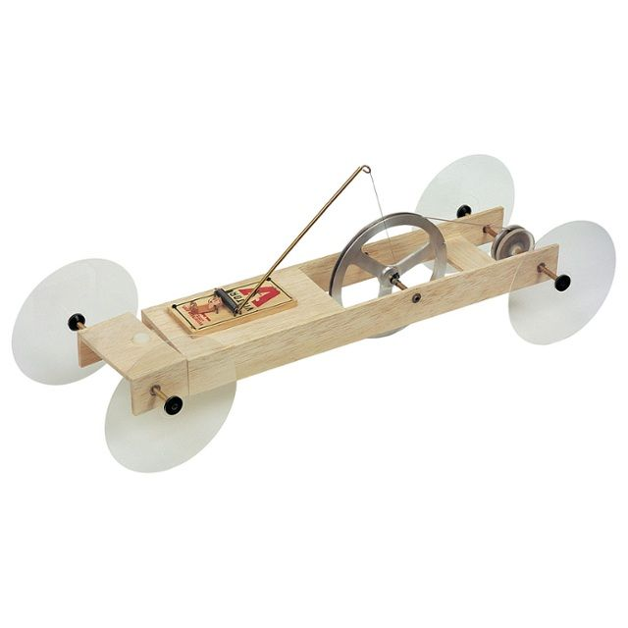

Figure 1 - Mousetrap car [1]

# **Learning Outcomes**

Students will learn the properties of a magnet. The basic principles of both Magnetism and Electromagnetism. Faraday’s and Lenz’s law. And to be able to tell the direction of the current flow through a coil using the Right-hand curl rule.

## Properties of a Magnet

Students will learn that a magnet has a north pole end and south pole end. As well as the magnetic field describes the forces that act around the magnet. The field lines travel from the north pole to the south pole. The width between field lines determines the strength of the magnetic field, i.e. wider equals weaker, and closer equals stronger. An illustration of this can be seen in Figure 2.

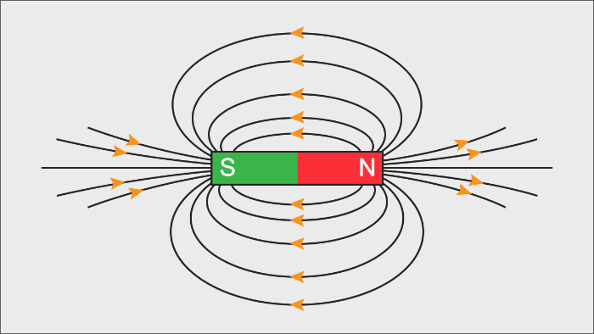

Figure 2 – Permanent magnet with field lines [2]

## Principle of Magnetism

Students will learn that magnetism is related to combing 1 or more magnets together. They will understand that there will be either an attraction or repulsion force taking place when combing 2 or magnets together. The figures below show the magnetic field strength of the magnet changing. Figure 3 shown the north pole of one magnet being attracted to the south of the other. Figure 4 shows repulsion occurring, i.e. when trying to add two like poles together. The strength of the magnetic can be seen in increasing in Figure 3 and decreasing in Figure 4.

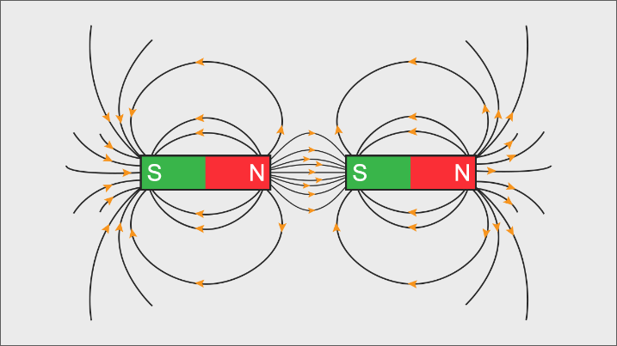

Figure 3 - Attraction between opposite poles [2]

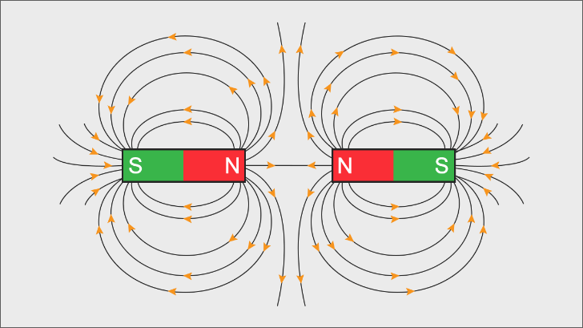

Figure 4 - Repulsion between like poles [2]

## Principle of Electromagnetism

Students will also learn about electromagnetism and the field that gets generated as an electric charge is present within a coiled loop. This phenomenon exists when an AC travels through a coiled loop. The electrical current creates an electric field around the charged particles as shown in Figure 5. An electric field is similar to a magnetic field but has positive and negative charges instead at the pole ends. This electric current in the coiled wire also creates a magnetic field.

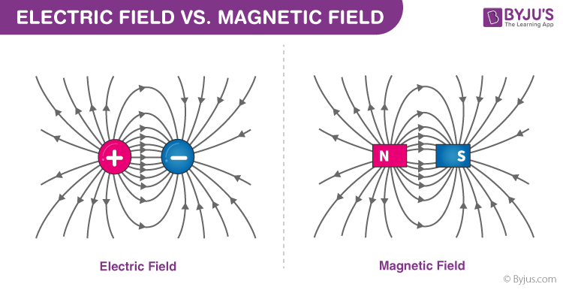

Figure 5 - Electric field [3]

## Faraday’s Principle of Electromagnetic Induction

Students will learn also learn about Faraday’s Electromagnetic Induction principle. Students will understand that by moving a magnet through a coil, they will have induced current through the coil. This is known as electromagnetic induction as by changing the magnetic field in the coil will induce an EMF in the loop of wire. This can be seen in Figure 6.

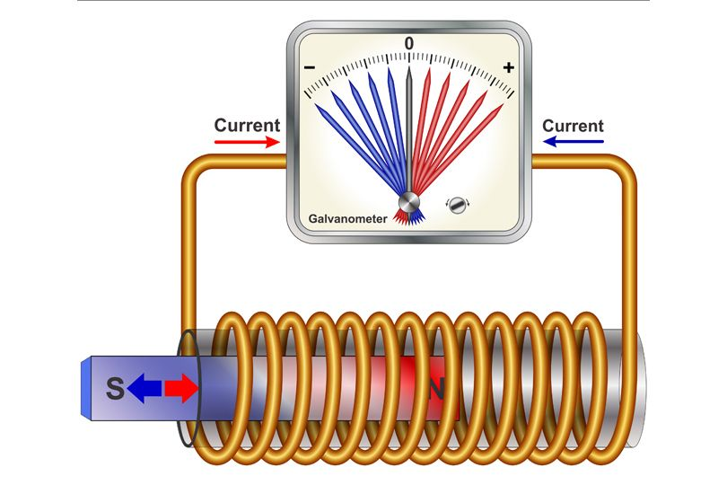

Figure 6 - Faraday's law [4]

Students will try and predict the two different input and output situations from using the simulator, as shown in Figure 7.

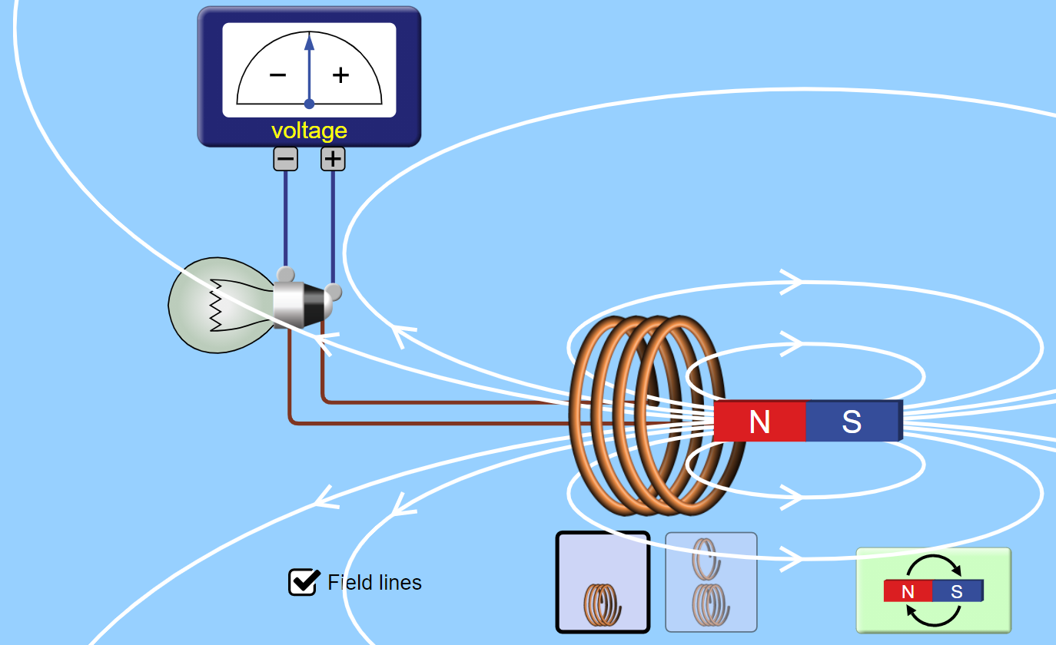

Figure 7 - Faraday's law simulation [5]

## Lenz’s law

Students will learn that Lenz’s law means that when a magnetic field of the coil is created by a moving magnet. The magnetic field of induced current, i.e. the coil, opposes the initial changing magnetic field. A representation of this can be seen in Figure 8.

Students will learn how to use Fleming’s right-hand rule to detect. Thumb is the direction of the current flow and the fingers show the magnetic field, as shown in Figure 8.

Figure 8 - Opposite the initial magnetic field [6]

Faraday’s and Lenz’s law equation describes the above behaviour’s. EMF is the voltage generated across the coil when a moving magnet passes through.

|  |  |
| --- | --- |
|  | (1) |

# **Motivation**

Since electric current can also be created without needing a battery. Using magnets could help minimize the world’s carbon footprint [7].

Chemicals are toxic and highly flammable, making chemical manufacturing plants extremely dangerous. And if not treated or looked after, the outcome can be disastrous. An example of this is shown in Figure 9. This show’s an explosion that occurred in Chenjiagang industrial park, Eastern China on the 21st of March 2019. On the 25th of March, there was a known of 78 fatalities and a further 566 injuries [8].



Figure 9 - Chemical plant explosion [8]

The combustion motor is known to be at least three times less efficient in terms of energy than the electric motor [9]. This again could help in reducing the world’s carbon footprint.

The earth as shown in an image in Appendix A shows a magnetic field that is repelling dangerous ionizing particles away from our earth. This repelling motion helps remove harmful radioactive solar wind and very far cosmic rays [10]. As you can see in Figure 10, the earth acts like one big magnet that keeps us safe.

Even, to this day, scientists still cannot say with 100% accuracy why our planet contains the same properties to a magnet. The running theory is that the molten metal that is continuously circling within the earth’s core, which generates powerful electric currents that form a magnetic field [2].

But if our earth didn’t have a magnetic field similar to the one in Figure 10, our world as we know it would cease to exist [11].

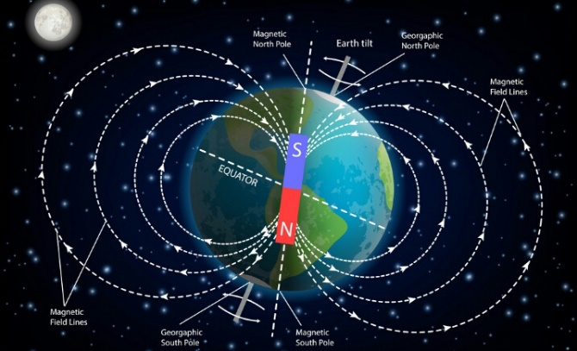

Figure 10 - Magnetic field of the earth [11]

# **Technical Experiments**

Students will get taught the learning outcomes of the project by conducting 3 experiments.

1. Making a Compass
2. Performing Faraday’s experiment
3. Make Faraday’s flashlight.

The time limit for the project was set to be less than 90 minutes long and for it to be done in a group of four students with one tutor.

## Experiment I – Compass

In experiment 1, students will learn both the properties of the magnet as discussed in section 3.1. As well as the principles of magnetism as discussed in 3.2. Students will also learn how to calibrate the compass by using their phone. The students should note that to start the 2nd experiment they must first know

The goal of this experiment is for students to determine the direction of the magnetic field of the magnet. On top of this, they must also mark the sides of the magnet like as shown in Figure 11.

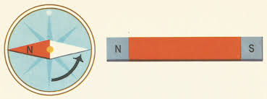

Figure 11 - Calibrating the magnet [12]

## Experiment II – Faraday’s Experiment

In experiment 2, students will perform Faraday’s experiment which teaches them about electromagnetism and electromagnetic induction as discussed in sections 3.3 and 3.4. They will also learn about Lenz’s law of electromagnetic induction to be able to determine the direction of the current as discussed in section 3.5.

The goal is to determine which coloured led will turn on first as the magnet passes through the coil. A schematic of this can be seen in Figure 12. The schematic shows two Led’s, one red with a volt drop of 2.25V and green, that has a volt drop of 2V. The number of turns (N) can be found by using Eq. (1) from section 3.5, the calculation for the number of turns shown in Appendix B and are pre-wound.

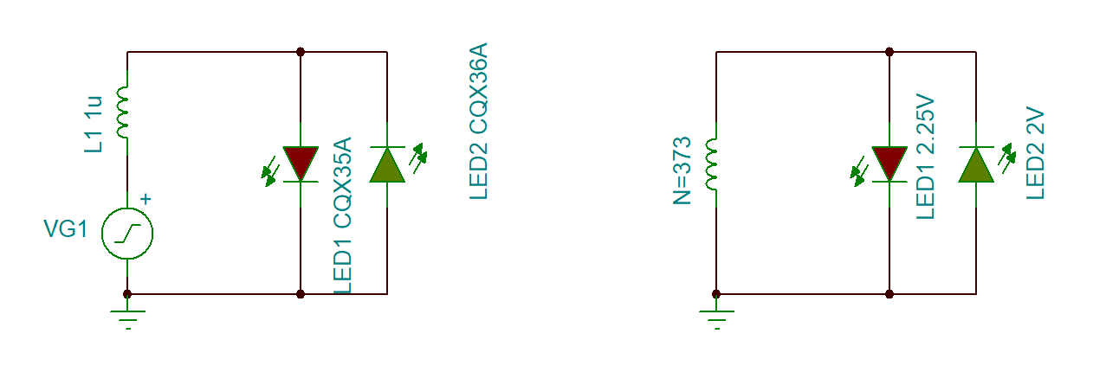

Figure 12 – Testing Faraday’s experiment

## Experiment III – Faraday’s flashlight

In experiment 3, students will make a flashlight as shown in Figure 13. The goal is to see which group can keep their flashlight on for the longest amount of time over a given period. The finished product should now show the student a practical use case that they made!

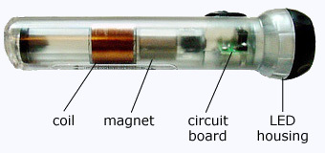

Figure 13 - Faraday's flashlight [13]

The schematic shown in Figure 14 shows the AC signal getting rectified into a DC signal. The 1 Farad super capacitor, stores and smooths the DC output. The capacitor takes 5 and a half minutes to fully charge up while keeping the white 3.2 V Led on. There is also a current limiting resistor for the Led to make sure the current stays below 20 mA.

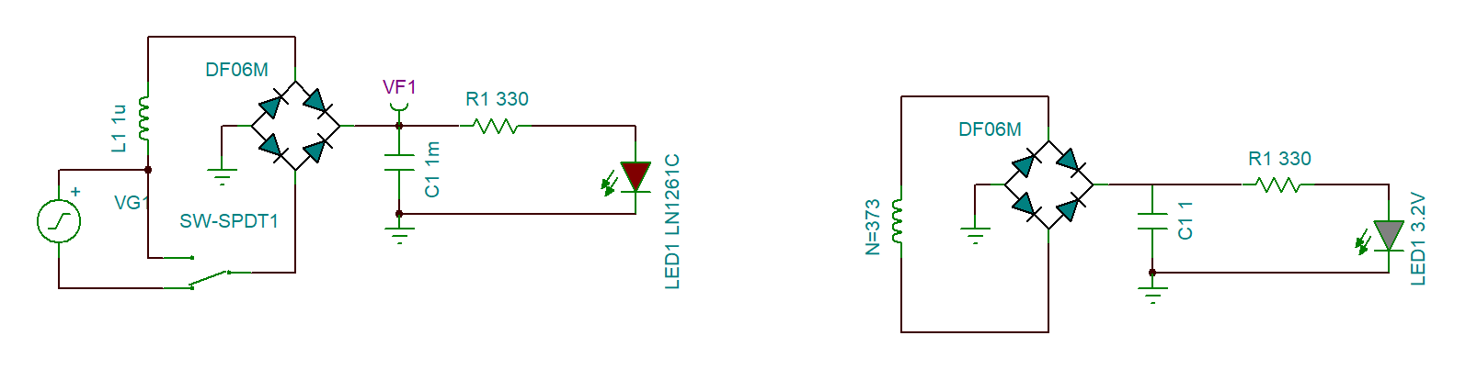

Figure 14 - Faraday's flashlight

# **Drawings and Design**

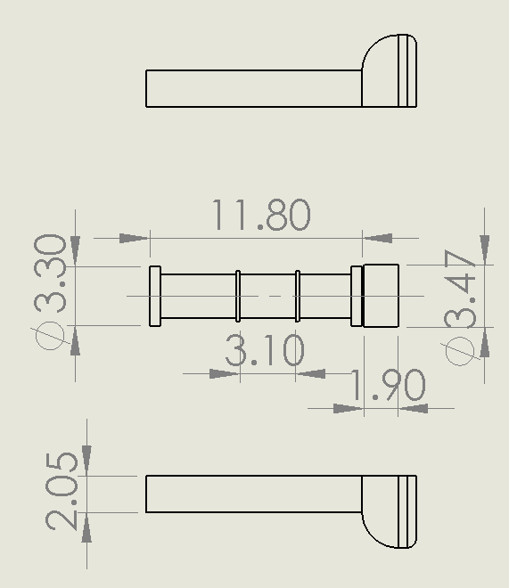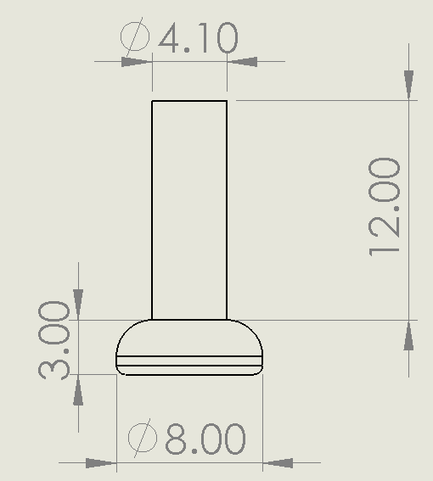 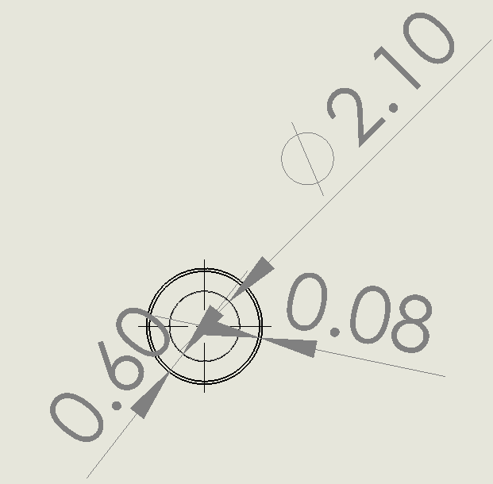

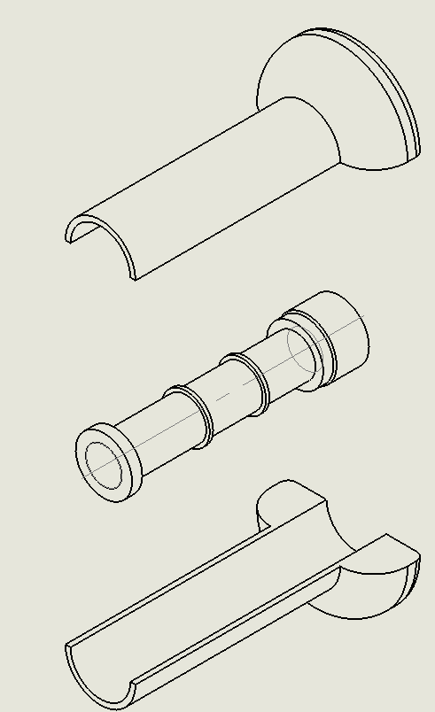

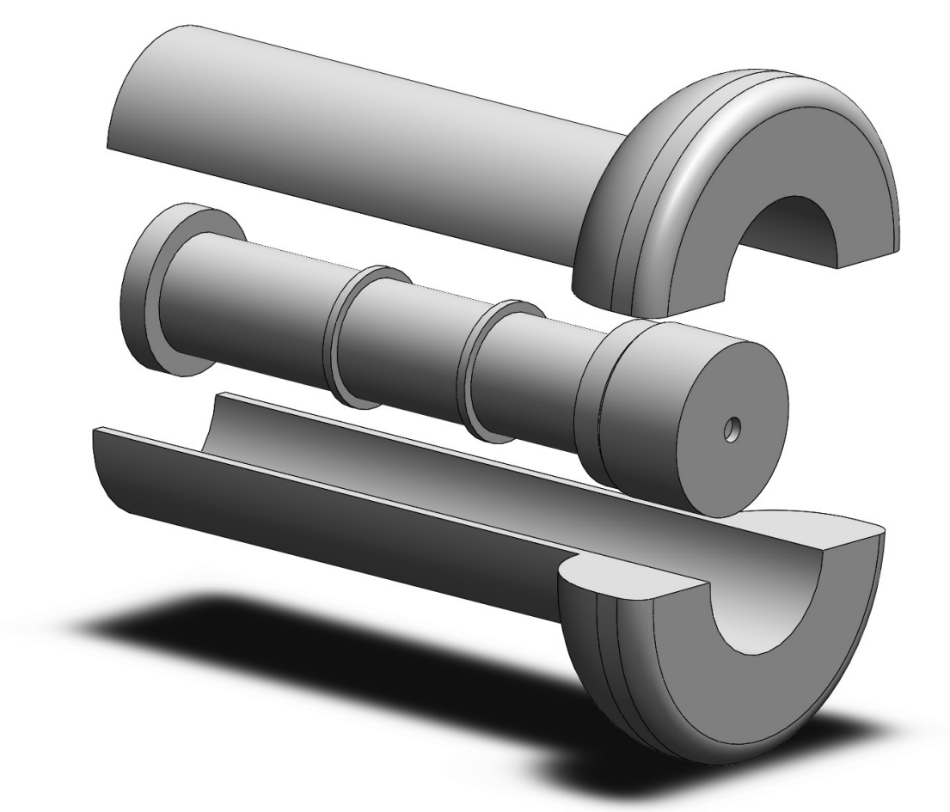

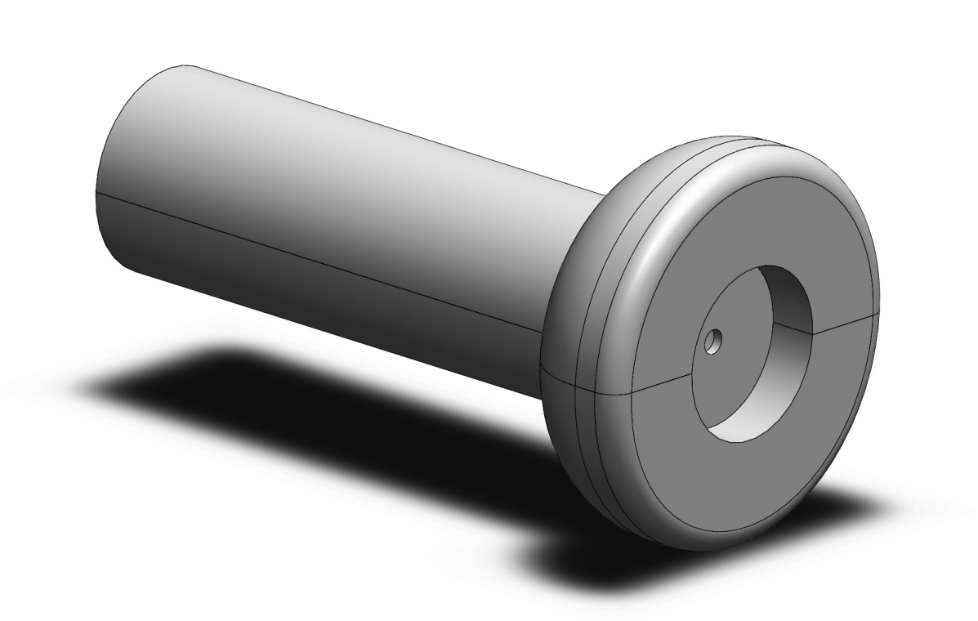

This section contains all of the required measurements for recreating the design above.

Notes:

* The 3.1 cm gap is where the coil will be rounded.
* The ends of the 11.8 cm pip are beam supporters.
* The 3.4 x 1.9 cm is a storage place for the circuit boards.
* At the end of the other side of the design, there is a cap which will seal the design
* When the design is assembled, the center skinny pipe is not connected to the actual top and bottom. This allows for easy accesses when something needs to be fixed.

# **Bill of materials**

Calculations billing shown below in Table 1, total costs were assuming that there will be 8 groups of 4 students per class of 32 students. The PCB (1-time cost per class) costs approximately $10 according to JLCPCB. 3D printing will be approximately $3.00 per unit, i.e., $24 per class.

The websites to where to buy these parts can be found in appendix C.

Table 1 – Bill cost for group and class

|  |  |  |  |  |  |
| --- | --- | --- | --- | --- | --- |
| Part List | Websites | | Quantity | | Price |
| Neodymium Cylinder magnet (20mm x 25mm) | Website 1 | |  | | $293.92 |
| Neodymium Disc magnet (8mm x 5mm) | Website 2 | |  | | $12.00 |
| DF06M (full bridge rectifier) | Website 3 | |  | | $4.40 |
| Copper wire (0.25mm) | Website 4 | |  | | $48.57 |
| Capacitor 1F (DK-6R3D105T) | Website 5 | |  | | $34.16 |
| Resistor (293-330-RC) | Website 6 | |  | | $1.00 |
| Green LED 2V (5mm) | Website 7 | |  | | $9.24 |
| Red LED 2.25V (5mm) | Website 8 | |  | | $8.60 |
| White LED 3.2V (5mm) | Website 9 | |  | | $15.66 |
| Corrugated Cardboard (1.5m x 1m) | Website 10 | |  | | $11.38 |
| Prestik | Website 11 | |  | | $4.30 |
| Homebrand Container | Website 12 | |  | | $6.00 |
| Total (class) | | $449.23 | |

The total cost per class comes to around $449.23. Some places only ship in bulk and so extra units had to be purchased. An addition of $34.00 will be added to the total class cost regarding printing costs.

# **Sustainability**

This project was about getting students in a group to work with together in trying to understand why magnets are useful. In terms of sustainability, the magnet is incredibly useful as it can both magnetize an object and also generates an electric current through a coiled wire. The magnet plays a vital role in our planet’s future in the goal of trying to minimize the world’s carbon footprint. This is especially true in the automotive industry where the petrol car is dependent on the natural resources that our planet provides, whereas electric cars rely on the human’s natural ability. i.e. such as Electric motors have proven to be a lot more efficient than a combustion one. In summary, the magnet is sustainable as it is environmentally friendly, Economical and gives back to others.

# **Conclusion**

The project was aimed to give each student a more in-depth look and a better understanding of magnets and their uses to mankind. The level of detail covered may be a challenge mentally for a student to grasp. This project was designed with the intent to teach them something, make them think, and to make something fun. Each group had to conduct 3 experiments where they learnt why magnets are useful in the real-world.

To summarize, magnetism provides us with numerous important advances. At its simplest level, you saw a compass which is vital for navigating around our world. I also went into great detail talking about the content the student would. I presented the bill of the materials as well as the 3D model used in the project. The final cost came down to of 32 students. talked to you about the advantages of moving a magnet through a coil to generate electricity.

Finally, I talked about sustainability, which is probably the most important reason to learn about magnets. Where magnets are vital components to the electric motor. Electric motors are currently being refined and stand to replace the combustion motor which will have a huge impact on our carbon footprint in the future.

# **References**

|  |  |
| --- | --- |
| [1] | N. BEARS, "Pinterest," [Online]. Available: https://www.pinterest.nz/pin/12947917658523896/?nic_v2=1awMiOCcA. [Accessed 14 10 2020]. |
| [2] | ScienceStruck, "ScienceStruck," 06 05 2015. [Online]. Available: https://sciencestruck.com/properties-uses-of-bar-magnet. [Accessed 10 10 2020]. |
| [3] | BYJU's, "BYJU's," 31 07 2020. [Online]. Available: https://byjus.com/physics/difference-between-electric-field-and-magnetic-field/. [Accessed 10 10 2020]. |
| [4] | J. Lucas, "Live Science," 28 01 2016. [Online]. Available: https://www.livescience.com/53509-faradays-law-induction.html. [Accessed 09 10 2020]. |
| [5] | Phet, "Phet," [Online]. Available: https://phet.colorado.edu/sims/html/faradays-law/latest/faradays-law_en.html. [Accessed 08 10 2020]. |
| [6] | FFDEN, "FFDEN," 14 08 2019. [Online]. Available: http://ffden-2.phys.uaf.edu/webproj/212_spring_2017/Max_Erickson/PrettyPhysicsProject/page2.html. [Accessed 12 10 2020]. |
| [7] | Bloomberg, "Industry Week," 16 10 2018. [Online]. Available: https://www.industryweek.com/technology-and-iiot/article/22026518/lithium-batteries-dirty-secret-manufacturing-them-leaves-massive-carbon-footprint. [Accessed 11 10 2020]. |
| [8] | K. Kan, "China Dialogue," 16 03 2019. [Online]. Available: https://chinadialogue.net/en/pollution/11159-china-s-latest-chemical-plant-explosion-was-avoidable/ . [Accessed 11 10 2020]. |
| [9] | M. Kelly, "RealClearEnergy," 18 03 2020. [Online]. Available: https://www.realclearenergy.org/articles/2020/03/18/electric_motors_versus_internal_combustion_engines_486956.html#:~:text=The%20first%20is%20that%20electric,electric%20battery%20in%2090%20seconds.. [Accessed 12 10 2020]. |
| [10] | Carnegie, "PHYSORG," 06 07 2020. [Online]. Available: https://phys.org/news/2020-07-earth-sustain-magnetic-field.html. [Accessed 12 10 2020]. |
| [11] | Tajamul, "Physics guide," 04 19 2020. [Online]. Available: https://www.themegaguide.com/2020/04/earth-magnetic-field.html. [Accessed 12 10 2020]. |
| [12] | D. Darling, "David Darling," 18 03 2016. [Online]. Available: https://www.daviddarling.info/childrens_encyclopedia/Magnetism_For_Kids.html. [Accessed 09 10 2020]. |
| [13] | P. Melloch+, "PowerGenSystems," 7 11 2012. [Online]. Available: https://www.powergensystem.com/technology/youtube-demonstration-of-faraday-s-flashlight/. [Accessed 09 10 2020]. |

# **Appendices**

# **Appendix: Motivation**

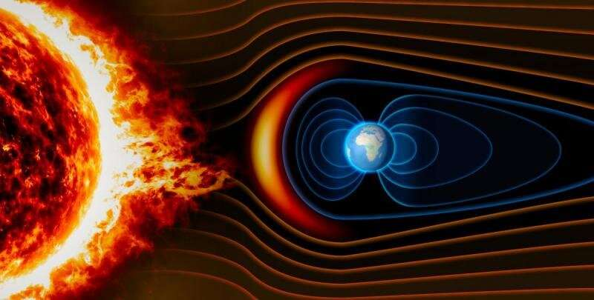

# **Appendix: Experiment II – Faraday’s Experiment**

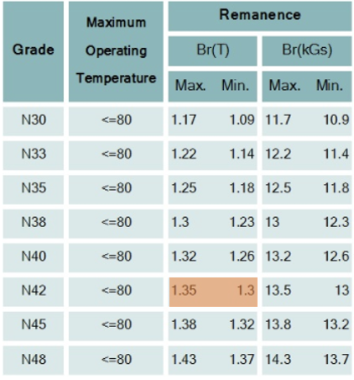

Table 2 - Neodymium Cylinder magnet (20mm x 25mm) - Website 1

(highest voltage drop)

Area of the coil (i.e. area of cylinder)

(D = 21 mm, r = 10.5 mm) – used online calculator

(Magnetic field) (Grade N42 magnet from Table 2 – taken from datasheet)

(average shaking frequency)

# **Appendix: Bill of materials**

Parts list websites:

Website 1 = <https://amfmagnets.co.nz/neodymium-cylinder-20mm-x-25mm.html>

Website 2 = <https://amfmagnets.co.nz/neodymium-disc-8mm-x-5mm.html>

Website 3 = <https://www.digikey.com/en/products/detail/on-semiconductor/DF06M/977156>

Website 4 = <https://nz.rs-online.com/web/p/copper-wire/0357716/>

Website 5 = <https://www.digikey.com/en/products/detail/elna-america/DK-6R3D105T/970179>

Website 6 = <https://www.digikey.com/en/products/detail/xicon/293-330-RC/10488067>

Website 7 = <https://nz.rs-online.com/web/p/leds/2286004/>

Website 8 = <https://nz.rs-online.com/web/p/leds/2285988/>

Website 9 = <https://nz.rs-online.com/web/p/leds/7133974/>

Website 10 = <https://www.coreblimey.co.nz/packaging/packaging-for-art/corrogated-cardboard-sheets-1-5m-x-1m/>

Website 11 = <http://www.swd.co.nz/shop/General+Office/Mounting+Products/Bostik+Prestik+And+Blu+Tack/Bostik+Prestik+100g-17574/x_sku/17574.html>

Website 12 = <https://shop.countdown.co.nz/shop/productdetails?stockcode=744029&gclid=CjwKCAjww5r8BRB6EiwArcckC5S_AqWq0UUE-YIqbLCYuRKzkUcoB70KnMZzS4DyMgYEqg7zTmrRpRoC4IcQAvD_BwE>



Why are

Magnets useful?

# **Tutors User Guide**

|  |  |
| --- | --- |
| **Key Concept**  Students will learn by conducting experiments to determine why magnets are useful. | **Aim**  This project aims to give students a more in-depth look and understanding of magnets and their usefulness to mankind. |
| **Time Allowed**   * Intro will take 5 min. * Experiment I will take 30 min. * Experiment II will take 25 min. * Experiment III will take 30 min.   **Year level’s**  8-10 | **Objectives**  At the end of the lesson, students will:   * Understand the properties of a Magnet (Taught in Experiment I) * Know what Magnetism is (Taught in Experiment II) * Know what Electromagnetism is (Taught in Experiment II) * Understand how Electromagnetic Induction works (Taught in Experiment II) * how it can be applied in the world (Taught in Experiment III) * Understand the engineering design process |
| **Subjects**  Physics  Engineering | **Method -** Students will conduct 3 different experiments to determine why magnets are useful.   * Experiment I will consist of making a compass * Experiment II will consist of performing Faraday’s experiment * Experiment III the student will make a flashlight |
| **Materials Supplied**   |  |  | | --- | --- | | Each group will get a list of the following: | | |  | 1 Container | |  | ½ a stick of Prestik | |  | 1 10x10 cm Corrugated Cardboard sheet | |  | 1 Neodymium Disc magnet | |  | 1 Neodymium Cylinder magnet | |  | 1 pair of scissors | |  | 1 Permanent marker | |  | 1 3D printed flashlight case | |  | 2 PCB circuit boards | | |

Note:

* + Please come prepared with a pencil, a ruler and a compass app on your phone
  + Before starting each experiment, please read the principles that are being taught

**Build Steps**

Experiment I

1. Cut a circle shape with your scissors on the piece of Corrugated Cardboard.
2. Take the ruler with your pencil and draw two lines that cross over each other at 90o. i.e. You there should be 4 distinct quadrants. If correct use the permanent marker.
3. Then label North, South, East and West. You should now have something similar to this.
4. 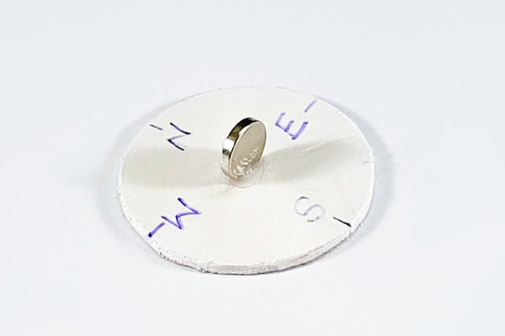Take a bit of Prestik and stick it in the centre of the cardboard. Then place the magnet on the Prestik. Note: the magnet has to be perpendicular to the surface.
5. Fill the container halfway up with water. Then place the piece of cardboard on the water surface so it floats.

(3)

1. Wait for a second and see what happens.
2. 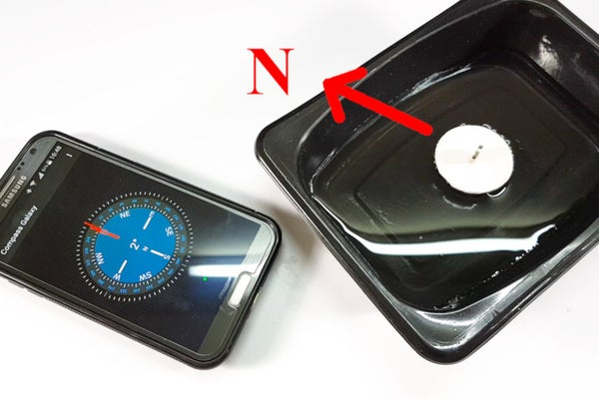Now open up the compass app on your phone and mark the north and south pole of the disc magnet with the permanent marker, i.e. dot for the north. If it is giving you an opposite reading for the disc magnet, flip it on the cardboard so it reads correctly with your phone.
3. **Learning point**
4. Finally, now that you have created the compass, now put it to use and identify the north and south poles on the Cylinder magnet.

(7)

1. **Learning point**

Experiment II

1. First Assemble the 3D printed sides.
2. Then slide the smaller pipe that has the coil into the case, make sure that the first small PCB is connected to the pipe.
3. Try shanking it without the magnet inside the smaller pipe.
4. **Learning point**
5. Place the magnet in and remember which way the magnet was orientated.
6. Now the students will predict which of the two Led’s will turn on. **Learning point** (hint - See Faraday’s and Lenz’s law)

If the student is still having no luck, try the simulator to get more of a mental picture.

Simulator = <https://phet.colorado.edu/sims/html/faradays-law/latest/faradays-law_en.html>

Experiment III

1. Students can either stay on for an extra 10 minutes for the 2nd experiment or move on to the 3rd. note: This is meant to be a fun competition between groups and the whole class.
2. They will learn that the principles and everything that they learnt have a use case at the end of the day. i.e. Useful for camping and where there are places with no/limited electricity.

page break